Global Academy of Technology
NAAC Accredited with ‘A’ Grade Rajarajeshwari Nagar, Bengaluru-560098
(Affiliated to Visvesvaraya Technological University, Belagavi)



Department of Computer Science and Engineering

15CSL67
System Software and Compiler Design / Operating Systems Laboratory

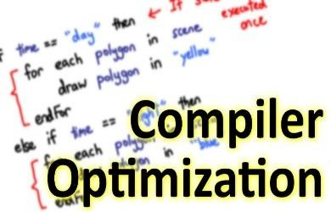




Prepared by: Faculties, Dept. of CSE

Table of Contents

Sl. No. | Particulars. |  | Page No.
1 | Vision and Mission of Institution |  | 1
2 | Vision and Mission of Department |  | 2
3 | PEO,PSO,PO |  | 3
4 | Course Details  - Course Objectives  - Syllabus  - Course Outcomes |  | 6
5 | CHAPTER 1 | Introduction to LEX
5 | 1.1 | Steps in writing LEX Program | 9
5 | 1.2 | Structure of LEX source program | 9
5 | 1.3 | Regular Expressions | 10
6 | CHAPTER 2 | Introduction to YACC
6 | 2.1 | Steps in writing YACC Program | 13
6 | 2.2 | Structure of YACC source program | 14
7 | CHAPTER 3 | Introduction to UNIX | 16
8 | CHAPTER 4 | Introduction to Operating Systems
8 | 5.1 | Scheduling Algorithms | 19
8 | 5.2 | Deadlocks | 19
9 | CHAPTER 5 | Lab Syllabus Programs
9 | Program 1 | - Write a LEX program to recognize valid arithmetic expression. Identifiers in the expression could be only integers and operators could be + and *. Count the identifiers &amp; operators present and print them separately.  - Write YACC program to evaluate arithmetic expression  involving operators: +, -, *, and /. | 20
9 | Program 2 | Develop, Implement and execute a program using YACC tool  to recognize all strings ending with b preceded by n a’s using the grammar a n b (note: input n value). | 23

 | Program 3 | Design, develop and implement YACC/C program to construct Predictive / LL(1) Parsing Table for the grammar rules: A →aBa , B →bB | ε. Use this table to parse the  sentence: abba$. | 24
 | Program 4 | Design, develop and implement YACC/C program to demonstrate Shift Reduce Parsing technique for the grammar rules: E →E+T | T, T →T*F | F, F →(E) | id and parse the  sentence: id + id * id. | 30
 | Program 5 | Design, develop and implement a C/Java program to generate the machine code using Triples for the statement A = -B * (C  +D) whose intermediate code in three-address form: T1 = -B  T2 = C + D  T3 = T1 + T2 A = T3 | 34
 | Program 6 | - Write a LEX program to eliminate comment lines in a C program and copy the resulting program into a separate file.  - Write YACC program to recognize valid identifier,  operators and keywords in the given text (C program) file. | 36
 | Program 7 | Design, develop and implement a C/C++/Java program to simulate the working of Shortest remaining time and Round Robin (RR) scheduling algorithms. Experiment with different  quantum sizes for RR algorithm. | 40
 | Program 8 | Design, develop and implement a C/C++/Java program to  implement Banker’s algorithm. Assume suitable input required to demonstrate the results. | 47
 | Program 9 | Design, develop and implement a C/C++/Java program to  implement page replacement algorithms LRU and FIFO. Assume suitable input required to demonstrate the results. | 52
 | Program 10 | - Design, develop and implement a C/C++/Java program to simulate a numerical calculator  - Design, develop and implement a C/C++/Java program to  simulate page replacement technique | 57
10 | CHAPTER 6 | Viva Questions | 68

Vision of the Institute

Become a premier institution imparting quality education in engineering and management to meet the changing needs of society.

Mission of the Institute

M1: Create environment conducive for continuous learning through quality teaching and learning processes supported by modern infrastructure.
M2: Promote Research and Innovation through collaboration with industries.
M3: Inculcate ethical values and environmental consciousness through holistic education programs.


DEPARTMENT OF COMPUTER SCIENCE AND ENGINEERING

VISION
Become a department that has good teaching and research environment for achieving academic excellence of students of Computer Science and Engineering and enabling them to meet emerging challenges of information technology.

MISSION
M1: To impart strong theoretical foundations in the field of Computer Science and Engineering accompanied with extensive practical training.
M2: To inculcate research and innovation spirit among students through interaction with industry and projects that address societal issues.
M3: Instill professional ethics and social values amongst students with concern for environment.

Program Educational Objectives (PEOs) of Department

After the course completion, CSE graduates will be able to:

PEO1: Succeed in engineering/management positions with professional Ethics.
PEO2: Engage in improving professional knowledge through Certificate/post - graduate programs in engineering or management.
PEO3: Establish themselves as entrepreneurs and contribute to the society.

Program Specific Outcomes (PSO)
PSO1: Design, Implement and test system software and application software to meet the desired needs.
PSO2: Develop solutions in the area of communication networks, Database systems and computing systems.

Program Outcomes (POs)

Engineering Graduates will be able to:

- Engineering knowledge: Apply the knowledge of mathematics, science, engineering fundamentals, and an engineering specialization to the solution of complex engineering problems.

- Problem analysis: Identify, formulate, review research literature, and analyze complex engineering problems reaching substantiated conclusions using first principles of mathematics, natural sciences, and engineering sciences.

- Design/development of solutions: Design solutions for complex engineering problems and design system components or processes that meet the specified needs with appropriate consideration for the public health and safety, and the cultural, societal, and environmental considerations.

- Conduct investigations of complex problems: Use research-based knowledge and research methods including design of experiments, analysis and interpretation of data, and synthesis of the information to provide valid conclusions.

- Modern tool usage: Create, select, and apply appropriate techniques, resources, and modern engineering and IT tools including prediction and modeling to complex engineering activities with an understanding of the limitations.

- The engineer and society: Apply reasoning informed by the contextual knowledge to assess societal, health, safety, legal and cultural issues and the consequent responsibilities relevant to the professional engineering practice.

- Environment and sustainability: Understand the impact of the professional engineering solutions in societal and environmental contexts, and demonstrate the knowledge of, and need for sustainable development.

- Ethics: Apply ethical principles and commit to professional ethics and responsibilities and norms of the engineering practice.

- Individual and team work: Function effectively as an individual, and as a member or leader in diverse teams, and in multidisciplinary settings.

- Communication: Communicate effectively on complex engineering activities with the engineering community and with society at large, such as, being able to comprehend and write effective reports and design documentation, make effective presentations, and give and receive clear instructions.

- Project management and finance: Demonstrate knowledge and understanding of the engineering and management principles and apply these to one’s own work, as a member and leader in a team, to manage projects and in multidisciplinary environments.

- Life-long learning: Recognize the need for, and have the preparation and ability to engage in independent and life-long learning in the broadest context of technological change.

.

Course Details

Course Name : System Software and Compiler Design / Operating Systems Lab
Course Code : 15CSL67
Course prerequisite : Basic Knowledge on Lex, YACC, C programming, UNIX
commands and shell scripts

Course Objectives

  - To make students familiar with Lexical Analysis and Syntax Analysis phases of Compiler Design and implement programs on these phases using LEX & YACC tools and/or C/C++/Java
  - To enable students to learn different types of CPU scheduling algorithms used in operating system.
  - To make students able to implement memory management - page replacement and deadlock handling algorithms

Syllabus

Subject Code : 15CSL67 | IA Marks 20
No. of Practical Hrs/ Week : 01I + 02P | Exam Hours : 03
Total No. of Practical Hrs : 40 | Exam Marks : 80
Description (If any): Exercises to be prepared with minimum three files (Where ever necessary):
    - Header file.
    - Implementation file.
    - Application file where main function will be present.
The idea behind using three files is to differentiate between the developer and user sides. In the developer side, all the three files could be made visible. For the user side only header file and application files could be made visible, which means that the object code of the implementation file could be given to the user along with the interface given in the header file, hiding the source file, if required. Avoid I/O operations (printf/scanf) and use data input file where ever it is possible

Laboratory Experiments:

- a) Write a LEX program to recognize valid arithmetic expression. Identifiers in the expression could be only integers and operators could be + and *. Count the identifiers & operators present and print them separately.
  - Write YACC program to evaluate arithmetic expression involving operators: +, -, *, and /.
- Develop, Implement and execute a program using YACC tool to recognize all strings ending with b
preceded by n a’s using the grammar a n b (note: input n value).
- Design, develop and implement YACC/C program to construct Predictive / LL(1) Parsing Table
for the grammar rules: A →aBa , B →bB | ε. Use this table to parse the sentence: abba$.
- Design, develop and implement YACC/C program to demonstrate Shift Reduce Parsing technique for the grammar rules: E →E+T | T, T →T*F | F, F →(E) | id and parse the sentence: id + id * id.
- Design, develop and implement a C/Java program to generate the machine code using Triples for the statement A = -B * (C +D) whose intermediate code in three-address form:
T1 = -B
T2 = C + D T3 = T1 + T2 A = T3
- a) Write a LEX program to eliminate comment lines in a C program and copy the resulting program into a separate file.
  - Write YACC program to recognize valid identifier, operators and keywords in the given text (C program) file.
- Design, develop and implement a C/C++/Java program to simulate the working of Shortest remaining time and Round Robin (RR) scheduling algorithms. Experiment with different quantum sizes for RR algorithm.
- Design, develop and implement a C/C++/Java program to implement Banker’s algorithm. Assume suitable input required to demonstrate the results.
- Design, develop and implement a C/C++/Java program to implement page replacement algorithms LRU and FIFO. Assume suitable input required to demonstrate the results.
- a) Design, develop and implement a C/C++/Java program to simulate a numerical calculator
  - Design, develop and implement a C/C++/Java program to simulate page replacement technique Note: In Examination, for question No 10: Students may be asked to execute any one of the above (10(a) or 10(b)- Examiner choice)

Course Outcomes
Upon successful completion of this course, students are able to:

15CSL67
System Software & Compiler Design / Operating Systems Lab
COs | COURSE OUTCOMES
CO1 | Implement and demonstrate Lexer’s and Parser’s
CO2 | Evaluate different algorithms required for management, scheduling,  allocation and communication used in operating system.

Conduction of Practical Examination:
- All laboratory experiments are to be included for practical examination.
- Students are allowed to pick one experiment from the lot.
- Strictly follow the instructions as printed on the cover page of answer script
- Marks distribution: Procedure + Conduction + Viva:20 + 50 +10 (80)
- Change of experiment is allowed only once and marks allotted to the procedure part to be made zero

- Introduction to LEX

Lex and YACC helps you write programs that transforms structured input. Lex generates C code for lexical analyzer whereas YACC generates Code for Syntax analyzer. Lexical analyzer is build using a tool called LEX. Input is given to LEX and lexical analyzer is generated.
Lex is a UNIX utility. It is a program generator designed for lexical processing of character input streams. Lex generates C code for lexical analyzer. It uses the patterns that match strings in the input and converts the strings to tokens. Lex helps you by taking a set of descriptions of possible tokens and producing a C routine, which we call a lexical analyzer. The token descriptions that Lex uses are known as regular expressions.

Steps in writing LEX Program:

1st step: Using gedit create a file with extension l. For example: prg1.l 2nd Step: lex prg1.l
3rd Step: cc lex.yy.c –ll
4th Step: ./a.out

Structure of LEX source program:

1stCol | 2ndCol | 3rdCol | 4thCol
 | DEFINITION SECTION
%%
 | RULE SECTION
%%
 | CODE SECTION

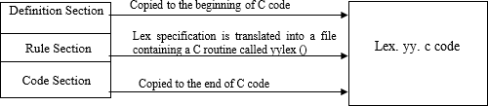

%% is a delimiter to the mark the beginning of the Rule section. The second %% is optional, but the first is required to mark the beginning of the rules. The definitions and the code /subroutines are often omitted

Lex variables

yyin | Of the type FILE*. This points to the current file being parsed by the lexer.
yyout | Of the type FILE*. This points to the location where the output of the lexer will be  written. By default, both yyin and yyout point to standard input and output.
yytext | The text of the matched pattern is stored in this variable (char*).
yyleng | Gives the length of the matched pattern.
yylineno | Provides current line number information. (May or may not be supported by the  lexer.)

Lex functions

yylex() | The function that starts the analysis. It is automatically generated by Lex.
yywrap() | This function is called when end of file (or input) is encountered. If this function returns 1, the parsing stops. So, this can be used to parse multiple files. Code can be written in the third section, which will allow multiple files to be parsed. The strategy is to make yyin file pointer (see the preceding table) point to a different file until all the files are parsed. At the end, yywrap() can return 1 to indicate end  of parsing.
yyless(int n) | This function can be used to push back all but first ‘n’ characters of the read token.
yymore() | This function tells the lexer to append the next token to the current token.

  - Regular Expressions
It is used to describe the pattern. It is widely used to in lex. It uses meta language. The character used in this meta language are part of the standard ASCII character set. An expression is made up of symbols. Normal symbols are characters and numbers, but there are other symbols that have special meaning in Lex. The following two tables define some of the symbols used in Lex and give a few typical examples.

Character | Meaning
A-Z, 0-9, a-z | Characters and numbers that form part of the pattern.
. | Matches any character except \n.
- | Used to denote range. Example: A-Z implies all characters from A to Z.
[ ] | A character class. Matches any character in the brackets. If the first character is  ^ then it indicates a negation pattern. Example: [abC] matches either of a, b, and C.

Character | Meaning
* | Match zero or more occurrences of the preceding pattern.
+ | Matches one or more occurrences of the preceding pattern.(no empty string)  Ex: [0-9]+ matches “1”,”111” or “123456” but not an empty string.
? | Matches zero or one occurrences of the preceding pattern.  Ex: -?[0-9]+ matches a signed number including an optional leading minus.
? | Matches zero or one occurrences of the preceding pattern.  Ex: -?[0-9]+ matches a signed number including an optional leading minus.
$ | Matches end of line as the last character of the pattern.
{ } | - Indicates how many times a pattern can be present. Example: A{1,3} implies one to three occurrences of A may be present.  - If they contain name, they refer to a substitution by that name.  Ex: {digit}
\ | Used to escape meta characters. Also used to remove the special meaning of characters as defined in this table.  Ex: \n is a newline character, while “\*” is a literal asterisk.
^ | Negation.
| | Matches either the preceding regular expression or the following regular  expression. Ex: cow|sheep|pig matches any of the three words.
"< symbols>" | Literal meanings of characters. Meta characters hold.
/ | Look ahead. Matches the preceding pattern only if followed by the succeeding  expression. Example: A0/1 matches A0 only if A01 is the input.
( ) | Groups a series of regular expressions together into a new regular expression.  Ex: (01) represents the character sequence 01. Parentheses are useful when building up complex patterns with *,+ and |

Examples of regular expressions

Regular  expression | Meaning
joke[rs] | Matches either jokes or joker.
A{1,2}shis+ | Matches AAshis, Ashis, AAshi, Ashi.
(A[b-e])+ | Matches zero or one occurrences of A followed by any character from b to e.
[0-9] | 0 or 1 or 2 or………9
[0-9]+ | 1 or 111 or 12345 or …At least one occurrence of preceding exp
[0-9]* | Empty string (no digits at all) or one or more occurrence.
-?[0-9]+ | -1 or +1 or +2 …..
[0.9]*\.[0.9]+ | 0.0,4.5 or .31415 But won’t match 0 or 2

Examples of token declarations

Token | Associated expression | Meaning
number | ([0-9])+ | 1 or more occurrences of a digit
chars | [A-Za-z] | Any character
blank | " " | A blank space
word | (chars)+ | 1 or more occurrences of chars
variable | (chars)+(number)*(chars)*( number)*

- Introduction to YACC

YACC provides a general tool for imposing structure on the input to a computer program. The input specification is a collection of grammar rules. Each rule describes an allowable structure and gives it a name. YACC prepares a specification of the input process. YACC generates a function to control the input process. This function is called a parser.
The name is an acronym for “Yet Another Compiler Compiler”. YACC generates the code for the parser in the C programming language. YACC was developed at AT& T for the Unix operating system. YACC has also been rewritten for other languages, including Java, Ada.
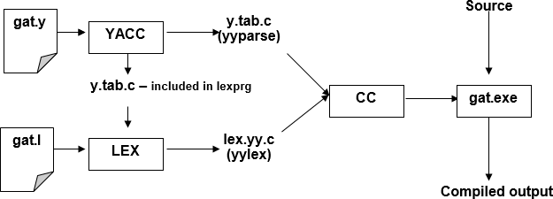
The function parser calls the lexical analyzer to pick up the tokens from the input stream. These tokens are organized according to the input structure rules .The input structure rule is called as grammar. When one of the rule is recognized, then user code supplied for this rule ( user code is action) is invoked. Actions have the ability to return values and makes use of the values of other actions.

Steps in writing YACC Program:

1st step: Usinggedit editor create a file with extension y. For example: prg1.y
2nd Step: YACC –d prg1.y
3rd Step: lex prg1.l
4th Step: cc y.tab.c lex.yy.c -ll
5th Step: /a.out

When we run YACC, it generates a parser in file y.tab.c and also creates an include file y.tab.h. To obtain tokens, YACC calls yylex. Function yylex has a return type of int, and returns the token. Values associated with the token are returned by lex in variable yylval.

Structure of YACC source program:

Basic Specification:

Every YACC specification file consists of three sections. The declarations, Rules (of grammars), programs. The sections are separated by double percent “%%” marks. The % is generally used in YACC specification as an escape character.

The general format for the YACC file is very similar to that of the Lex file.
1stCol | 2ndCol | 3rdCol | 4thCol
 | DEFINITION SECTION
%%
 | RULE SECTION
%%
 | CODE SECTION

%% is a delimiter to the mark the beginning of the Rule section.

Definition Section

%union | It defines the Stack type for the Parser. It is a union of various datas/structures/  objects
%token | These are the terminals returned by the yylex function to the YACC. A token can also have type associated with it for good type checking and syntax directed translation. A type of a token can be specified as %token <stack member>tokenName.  Ex: %token NAME NUMBER
%type | The type of a non-terminal symbol in the Grammar rule can be specified with  this.The format is %type <stack member>non-terminal.
%noassoc | Specifies that there is no associatively of a terminal symbol.
%left | Specifies the left associatively of a Terminal Symbol
%right | Specifies the right associatively of a Terminal Symbol.
%start | Specifies the L.H.S non-terminal symbol of a production rule which should be  taken as the starting point of the grammar rules.
%prec | Changes the precedence level associated with a particular rule to that of the  following token name or literal

Rules Section
The rules section simply consists of a list of grammar rules. A grammar rule has the form: A: BODY
A represents a nonterminal name, the colon and the semicolon are YACC punctuation and BODY represents names and literals. The names used in the body of a grammar rule may represent tokens or nonterminal symbols. The literal consists of a character enclosed in single quotes.

Names representing tokens must be declared as follows in the declaration sections:
%token name1 name2…

Every name not defined in the declarations section is assumed to represent a non-terminal symbol. Every non-terminal symbol must appear on the left side of at least one rule. Of all the no terminal symbols, one, called the start symbol has a particular importance. The parser is designed to recognize the start symbol. By default the start symbol is taken to be the left hand side of the first grammar rule in the rules section.

With each grammar rule, the user may associate actions to be. These actions may return values, and may obtain the values returned by the previous actions. Lexical analyzer can return values for tokens, if desired. An action is an arbitrary C statement. Actions are enclosed in curly braces.

Introduction to UNIX
Basic UNIX commands

Folder/Directory Commands and Options

Action | UNIX options & filespec
Check current Print Working Directory | pwd
Return to user's home folder | cd
Up one folder | cd ..
Make directory | mkdir proj1
Remove empty directory | rmdir/usr/sam
Remove directory-recursively | rm -r

File Listing Commands and Options

Action | UNIX options & filespec
List directory tree- recursively | ls -r
List last access dates of files, with hidden files | ls -l -a
List files by reverse date | ls -t -r *.*
List files verbosely by size of file | ls -l -s *.*
List files recursively including contents of other directories | ls -R *.*
List number of lines in folder | wc -l *.xtumlsed -n '$='
List files with x anywhere in the name | ls | grep x

File Manipulation Commands and Options

Action | UNIX options&filespec
Create new(blank)file | touch afilename
Copy old file to new file. -p preserve file attributes(e.g. ownership and edit dates)-r copy recursively through directory structure -a archive, combines the flags-p – R and-d | cp old.filenew.file
Move old.file(-i interactively flag prompts before overwriting files) | mv –i old.file/tmp
Remove file(-intention) | rm –i sam.txt
Compare two files and show differences | diff

File Utilities

Action | UNIX options & filespec
View a file | vi file.txt
Concatenate files | cat file1file2 to standard output.
Counts-lines,-words, and- characters in a file | wc -l
Displays line-by-line differences between pairs of text files. | diff
calculator | bc
calendar for September, 1752 (when leap years began) | cal 9 1752

Controlling program execution for C-shell

& | Run job in background
^c | Kill job in foreground
^z | Suspend job in foreground
Fg | Restart suspended job in foreground
Bg | Run suspended job in background
; | Delimit commands on same line
() | Group commands on same line
! | re-run earlier commands from history list
jobs | List current jobs

Controlling program input/output for C-shell

| | Pipe output to input
> | Redirect output to a storage file
< | Redirect input from a storage file
>> | Append redirected output to a storage file
tee | Copy input to both file and next program in pipe
script | Make file record of al terminal activity

- Introduction to Operating Systems
Introduction

An Operating System is a program that manages the Computer hardware. It controls and coordinates the use of the hardware among the various application programs for the various users.

A Process is a program in execution. As a process executes, it changes state
- New : The process is being created
- Running : Instructions are being executed
- Waiting : The process is waiting for some event to occur
- Ready : The process is waiting to be assigned to a process
- Terminated : The process has finished execution
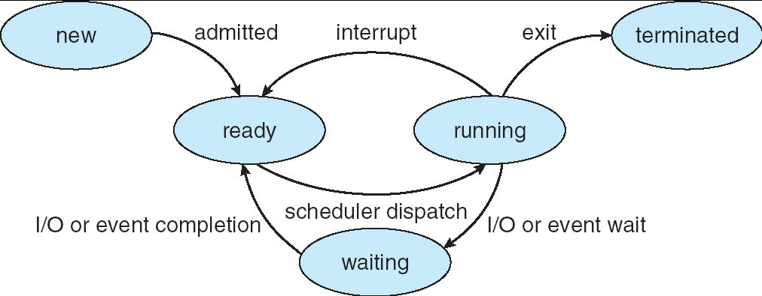
Apart from the program code, it includes the current activity represented by
- Program Counter,
- Contents of Processor registers,
- Process Stack which contains temporary data like function parameters, return addresses and local variables
- Data section which contains global variables
- Heap for dynamic memory allocation

A Multi-programmed system can have many processes running simultaneously with the CPU multiplexed among them. By switching the CPU between the processes, the OS can make the computer more productive. There is Process Scheduler which selects the process among many processes that are ready, for program execution on the CPU. Switching the CPU to another process requires performing a state save of the current process and a state restore of new process, this is Context Switch.

  - Scheduling Algorithms

CPU Scheduler can select processes from ready queue based on various scheduling algorithms. Different scheduling algorithms have different properties, and the choice of a particular algorithm may favor one class of processes over another. The scheduling criteria include

    - CPU utilization:
    - Throughput: The number of processes that are completed per unit time.
    - Waiting time: The sum of periods spent waiting in ready queue.
    - Turnaround time: The interval between the time of submission of process to the time of completion.
    - Response time: The time from submission of a request until the first response is produced.

The different scheduling algorithms are

    - FCFS: First Come First Served Scheduling
    - SJF: Shortest Job First Scheduling
    - SRTF: Shortest Remaining Time First Scheduling
    - Priority Scheduling
    - Round Robin Scheduling
    - Multilevel Queue Scheduling
    - Multilevel Feedback Queue Scheduling

  - Deadlocks

A process requests resources; and if the resource is not available at that time, the process enters a waiting state. Sometimes, a waiting process is never able to change state, because the resource is has requested is held by another process which is also waiting. This situation is called Deadlock.
Deadlock is characterized by four necessary conditions
    - Mutual Exclusion
    - Hold and Wait
    - No Preemption
    - Circular Wait

Deadlock can be handled in one of these ways,
    - Deadlock Avoidance
    - Deadlock Detection and Recover

Lab Syllabus Programs

1 a. Write a LEX program to recognize valid arithmetic expression. Identifiers in the expression could be only integers and operators could be + and *. Count the identifiers & operators present and print them separately.

%{
#include<stdio.h>
int v=0,op=0,id=0,flag=0;
%}
%%
[a-zA-Z]+[0-9A-Za-z]* {id++;printf("\n Identifier:");ECHO;} [\+\-\*\/\=] {op++;printf("\n Operartor:");ECHO;}
"(" {v++;}
")" {v--;}
";" {flag=1;}
.|\n {;}
%%
main()
{
printf("Enter the expression"); yylex();
if((op+1) ==id && v==0 && flag==0) printf("\n Expression is Valid\n");
else
printf("\n Expression is Invalid\n");
}
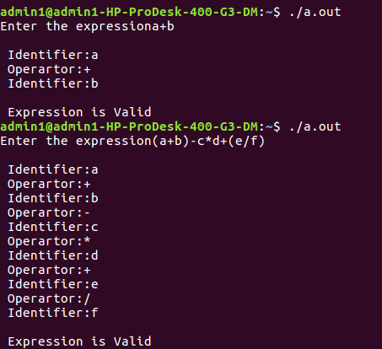
Execution Steps:
Lex <lexfilename.l> cc lex.yy.c –ll
. /a.out <temp.txt>

Output:

b. Write YACC program to evaluate arithmetic expression involving operators: +, -, *, and /
Lex Part
%{
#include "y.tab.h" extern yylval;
%}
%%
[0-9]+ {yylval=atoi(yytext);return num;} /* convert the string to number and

send the value*/

[\+\-\*\/] {return yytext[0];} [)] {return yytext[0];}
[(] {return yytext[0];}
. {;}
\n {return 0;}
%%

%{
#include<stdio.h> #include<stdlib.h>
%}
%token num
%left '+' '-'
%left '*' '/'
%%
input:exp {printf("%d\n",$$);exit(0);} exp:exp'+'exp {$$=$1+$3;}
|exp'-'exp{$$=$1-$3;}
|exp'*'exp{$$=$1*$3;}

YACC Part

|exp'/'exp { if($3==0){printf("Divide by Zero\n");exit(0);} else
$$=$1/$3;}
|'('exp')'{$$=$2;}
|num{$$=$1;};
%%
int yyerror()
{
printf("error"); exit(0);
}

int main()
{
printf("Enter an expression:\n");

yyparse();
}

Output:
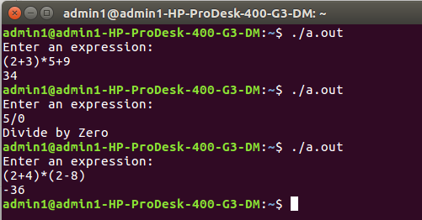

Develop, Implement and execute a program using YACC tool to recognize all strings ending with
b preceded by n a’s using the grammar a n b (note: input n value).

%{
#include "y.tab.h"
%}
%%
a {return A;} b {return B;}
[\n] return '\n';
%%

Lex Part

%{
#include<stdio.h> #include<stdlib.h>
%}
%token A B
%%

YACC Part

input:s'\n' {printf("Successful Grammar\n");exit(0);} s: A s1 B| B
s1: ; | A s1
%%
main()
{
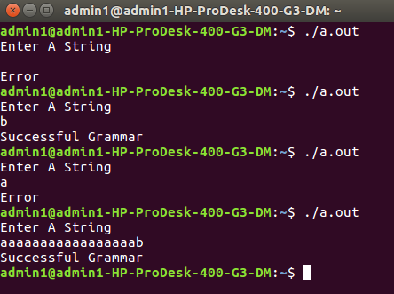
printf("Enter A String\n"); yyparse();
}

int yyerror()
{
printf("Error \n"); exit(0);
}

Output:

- Design, develop and implement YACC/C program to construct Predictive / LL(1) Parsing Table
for the grammar rules: A →aBa , B →bB | ε. Use this table to parse the sentence: abba$.
#include<stdio.h> #include<conio.h> #include<string.h> void main()
{
char fin[10][20],st[10][20],ft[20][20],fol[20][20];
int a=0,e,i,t,b,c,n,k,l=0,j,s,m,p; printf("enter the no. of coordinates\n"); scanf("%d",&n);
printf("enter the productions in a grammar\n"); for(i=0;i<n;i++)
scanf("%s",st[i]); for(i=0;i<n;i++) fol[i][0]='\0'; for(s=0;s<n;s++)
{
for(i=0;i<n;i++)
{ j=3; l=0; a=0;
l1:if(!((st[i][j]>64)&&(st[i][j]<91)))
{
for(m=0;m<l;m++)
{
if(ft[i][m]==st[i][j]) goto s1;
}
ft[i][l]=st[i][j]; l=l+1; s1:j=j+1;
}
else
{
if(s>0)
{
while(st[i][j]!=st[a][0])
{ a++;
} b=0;
while(ft[a][b]!='\0')
{
for(m=0;m<l;m++)
{
if(ft[i][m]==ft[a][b]) goto s2;
}
ft[i][l]=ft[a][b]; l=l+1; s2:b=b+1;
}
}
}
while(st[i][j]!='\0')
{
if(st[i][j]=='|')
{
j=j+1; goto l1;
}
j=j+1;
}
ft[i][l]='\0';
}
}
printf("first pos\n"); for(i=0;i<n;i++)
printf("FIRS[%c]=%s\n",st[i][0],ft[i]); fol[0][0]='$';
for(i=0;i<n;i++)
{ k=0; j=3;
if(i==0) l=1;
else l=0;
k1:while((st[i][0]!=st[k][j])&&(k<n))
{
if(st[k][j]=='\0')
{ k++; j=2;
} j++;
}
j=j+1; if(st[i][0]==st[k][j-1])
{
if((st[k][j]!='|')&&(st[k][j]!='\0'))
{ a=0;
if(!((st[k][j]>64)&&(st[k][j]<91)))
{
for(m=0;m<l;m++)
{
if(fol[i][m]==st[k][j]) goto q3;
}
q3: fol[i][l]=st[k][j]; l++;

}
else
{
while(st[k][j]!=st[a][0])
{ a++;
} p=0;
while(ft[a][p]!='\0')

{
if(ft[a][p]!='@')
{
for(m=0;m<l;m++)
{
if(fol[i][m]==ft[a][p]) goto q2;
}
fol[i][l]=ft[a][p]; l=l+1;
}
else e=1; q2:p++;
}
if(e==1)
{ e=0;
goto a1;
}
}
}
else
{ a1:c=0; a=0;
while(st[k][0]!=st[a][0])
{ a++;

}
while((fol[a][c]!='\0')&&(st[a][0]!=st[i][0]))
{
for(m=0;m<l;m++)
{
if(fol[i][m]==fol[a][c]) goto q1;
}
fol[i][l]=fol[a][c]; l++;
q1:c++;
}
}
goto k1;
}
fol[i][l]='\0';
}
printf("follow pos\n"); for(i=0;i<n;i++)
printf("FOLLOW[%c]=%s\n",st[i][0],fol[i]); printf("\n");
s=0;
for(i=0;i<n;i++)
{ j=3;
while(st[i][j]!='\0')
{
if((st[i][j-1]=='|')||(j==3))
{
for(p=0;p<=2;p++)
{
fin[s][p]=st[i][p];
}
t=j; for(p=3;((st[i][j]!='|')&&(st[i][j]!='\0'));p++)
{
fin[s][p]=st[i][j]; j++;
}
fin[s][p]='\0';
if(st[i][t]=='@')
{ b=0; a=0;
while(st[a][0]!=st[i][0])
{ a++;
}
while(fol[a][b]!='\0')
{
printf("M[%c,%c]=%s\n",st[i][0],fol[a][b],fin[s]); b++;
}
}
else if(!((st[i][t]>64)&&(st[i][t]<91)))
printf("M[%c,%c]=%s\n",st[i][0],st[i][t],fin[s]); else
{ b=0;

a=0;
while(st[a][0]!=st[i][3])
{ a++;
}
while(ft[a][b]!='\0')
{
printf("M[%c,%c]=%s\n",st[i][0],ft[a][b],fin[s]); b++;
}
} s++;
}
if(st[i][j]=='|') j++;
}
}
getch();
}

Output:
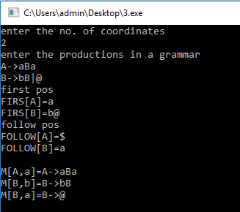
- Design, develop and implement YACC/C program to demonstrate Shift Reduce Parsing technique for the grammar rules: E →E+T | T, T →T*F | F, F → (E) | id and parse the sentence: id + id * id.
A parser is a compiler or interpreter component that breaks data into smaller elements for easy translation into another language. A parser takes input in the form of a sequence of tokens or program instructions and usually builds a data structure in the form of a parse tree or an abstract syntax tree.
A parser's main purpose is to determine if input data may be derived from the start symbol of the grammar.
Syntax analyzers follow production rules defined by means of context-free grammar. The way the production rules are implemented (derivation) divides parsing into two types: top-down parsing and bottom-up parsing.
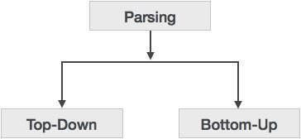

Top-down Parsing
When the parser starts constructing the parse tree from the start symbol and then tries to transform the start symbol to the input, it is called top-down parsing.
- Recursive descent parsing: It is a common form of top-down parsing. It is called recursive as it uses recursive procedures to process the input. Recursive descent parsing suffers from backtracking.
- Backtracking: It means, if one derivation of a production fails, the syntax analyzer restarts the process using different rules of same production. This technique may process the input string more than once to determine the right production.

Bottom-up Parsing
Bottom-up parsing starts with the input symbols and tries to construct the parse tree up to the start symbol.

Shift-reduce Parsing (Bottom-up Parsing)
Shift-reduce parsing attempts to construct a parse tree for an input string beginning at the leaves and working up towards the root. In other words, it is a process of “reducing” (opposite of deriving a symbol using a production rule) a string w to the start symbol of a grammar. At every (reduction) step, a particular substring matching the RHS of a production rule is replaced by the symbol on the LHS of the production.
A general form of shift-reduce parsing is LR (scanning from Left to right and using Right-most derivation in reverse) parsing, which is used in a number of automatic parser generators like Yacc, Bison, etc.
#include<stdio.h> #include<conio.h> #include<string.h>
int k=0,z=0,i=0,j=0,c=0;
char a[16],ac[20],stk[15],act[10]; void check();
void main()
{
puts("GRAMMAR is E->E+E \n E->E*E \n E->(E) \n E->id"); puts("enter input string ");
gets(a); c=strlen(a);
strcpy(act,"SHIFT->"); puts("stack \t input \t action"); for(k=0,i=0; j<c; k++,i++,j++)
{
if(a[j]=='i' && a[j+1]=='d')
{
stk[i]=a[j];
stk[i+1]=a[j+1];
stk[i+2]='\0';
a[j]=' ';
a[j+1]=' ';
printf("\n$%s\t%s$\t%sid",stk,a,act); check();
}
else
{
stk[i]=a[j];
stk[i+1]='\0';
a[j]=' ';
printf("\n$%s\t%s$\t%ssymbols",stk,a,act); check();
}
}
getch();
}
void check()
{
strcpy(ac,"REDUCE TO E"); for(z=0; z<c; z++)
if(stk[z]=='i' && stk[z+1]=='d')
{
stk[z]='E';
stk[z+1]='\0'; printf("\n$%s\t%s$\t%s",stk,a,ac); j++;
}
for(z=0; z<c; z++)
if(stk[z]=='E' && stk[z+1]=='+' && stk[z+2]=='E')
{
stk[z]='E';
stk[z+1]='\0';
stk[z+2]='\0'; printf("\n$%s\t%s$\t%s",stk,a,ac); i=i-2;
}
for(z=0; z<c; z++)
if(stk[z]=='E' && stk[z+1]=='*' && stk[z+2]=='E')
{
stk[z]='E';
stk[z+1]='\0';
stk[z+1]='\0'; printf("\n$%s\t%s$\t%s",stk,a,ac); i=i-2;
}
for(z=0; z<c; z++)
if(stk[z]=='(' && stk[z+1]=='E' && stk[z+2]==')')
{
stk[z]='E';
stk[z+1]='\0';
stk[z+1]='\0';
printf("\n$%s\t%s$\t%s",stk,a,ac); i=i-2;
}
}
Output:
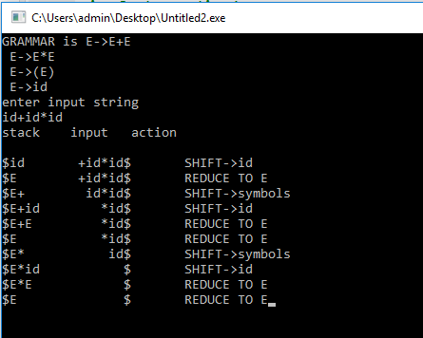
- Design, develop and implement a C/Java program to generate the machine code using Triples for the statement A = -B * (C +D) whose intermediate code in three-address form:
T1 = -B
T2 = C + D T3 = T1 * T2 A = T3
#include<stdio.h> #include<stdlib.h> #include<ctype.h>
char op[2],arg1[5],arg2[5],result[5]; void main()
{
FILE *fp1,*fp2; fp1=fopen("input.txt","r");
fp2=fopen("output.txt","w");

while(!feof(fp1))
{

fscanf(fp1,"%s%s%s%s",result,arg1,op,arg2); if(strcmp(op,"+")==0)
{
fprintf(fp2,"\nMOV R0,%s",arg1); fprintf(fp2,"\nADD R0,%s",arg2); fprintf(fp2,"\nMOV %s,R0",result);

}
if(strcmp(op,"*")==0)
{
fprintf(fp2,"\nMOV R0,%s",arg1);

fprintf(fp2,"\nMUL R0,%s",arg2); fprintf(fp2,"\nMOV %s,R0",result);
}
if(strcmp(op,"-")==0)
{
fprintf(fp2,"\nMOV R0,%s",arg1); fprintf(fp2,"\nSUB R0,%s",arg2); fprintf(fp2,"\nMOV %s,R0",result);
}
if(strcmp(op,"/")==0)
{
fprintf(fp2,"\nMOV R0,%s",arg1); fprintf(fp2,"\nDIV R0,%s",arg2); fprintf(fp2,"\nMOV %s,R0",result);
}
if(strcmp(op,"=")==0)
{
fprintf(fp2,"\nMOV R0,%s",arg1); fprintf(fp2,"\nMOV %s,R0",result);
}
}
fclose(fp1); fclose(fp2); getch();
}
Output:

input.txt
T1 -B = ? T2 C + D T3 T1 * T2 A T3 = ?
output.txt
MOV R0,-B MOV T1,R0 MOV R0,C ADD R0,D MOV T2,R0 MOV R0,T1 MUL R0,T2 MOV T3,R0 MOV R0,T3 MOV A,R0
- a) Write a LEX program to eliminate comment lines in a C program and copy the resulting program into a separate file.
%{
#include<stdio.h> int c_count=0;
%}
%%
"/*"[^*/]*"*/" {c_count++;} /*for single and multiple line comments*/
"//".* {c_count++;} /*for single line comments*/

%%
int main( int argc, char **argv)
{
FILE *f1,*f2;
if(argc>1) /*Pass two filenames for execution*/
{
f1=fopen(argv[1],"r"); /*open first file for reading*/
if(!f1) /*not able to open file*/
{
printf("file error \n"); exit(1);
}
yyin=f1;
f2=fopen(argv[2],"w"); /*open second file for writing*/
if(!f2) /*not able to open file*/
{
printf("Error"); exit(1);
}
yyout=f2;

yylex();
printf("Number of Comment Lines: %d\n",c_count);
}
return 0;
}
OUTPUT:
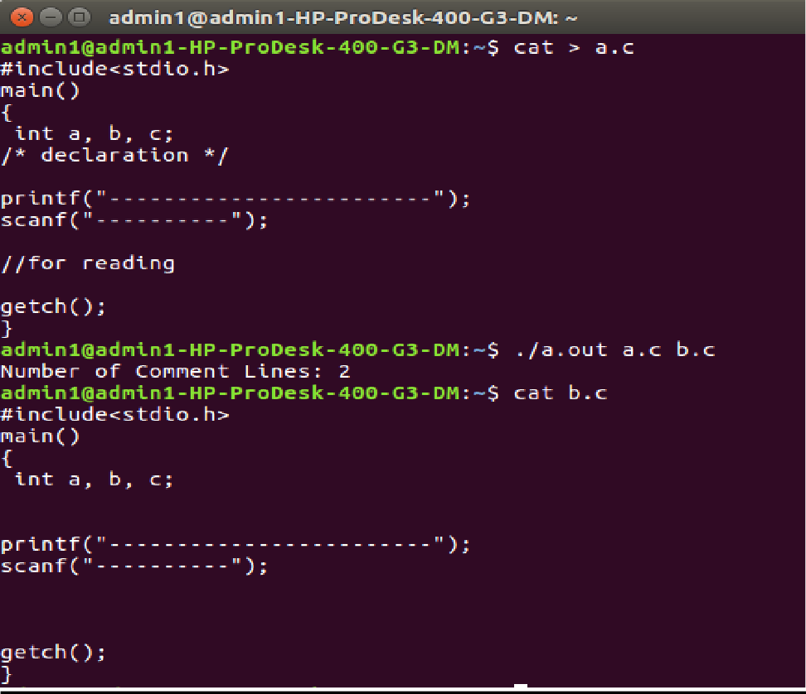
b) Write YACC program to recognize valid identifier, operators and keywords in the given text (C program) file.

Lex File
%{
#include <stdio.h> #include "y.tab.h" extern yylval;
%}
%%
[ \t] ;
[+|-|*|/|=|<|>] {printf("operator is %s\n",yytext);return OP;}
[0-9]+ {yylval = atoi(yytext); printf("numbers is %d\n",yylval); return DIGIT;} int|char|bool|float|void|for|do|while|if|else|return|void {printf("keyword is
%s\n",yytext);return KEY;}
[a-zA-Z0-9]+ {printf("identifier is %s\n",yytext);return ID;}
. ;
%%

Yacc File
%{
#include <stdio.h> #include <stdlib.h>
int id=0, dig=0, key=0, op=0;
%}
%token DIGIT ID KEY OP
%%
input:
DIGIT input { dig++; }
| ID input { id++; }
| KEY input { key++; }
| OP input {op++;}
| DIGIT { dig++; }
| ID { id++; }
| KEY { key++; }
| OP { op++;}
;
%%
#include <stdio.h> extern int yylex(); extern int yyparse(); extern FILE *yyin; main() {
FILE *myfile = fopen("sam_input.c", "r"); if (!myfile) {
printf("I can't open sam_input.c!"); return -1;
}
yyin = myfile; do { yyparse();
} while (!feof(yyin));
printf("numbers = %d\nKeywords = %d\nIdentifiers = %d\noperators = %d\n", dig, key,id, op);
}
void yyerror() {
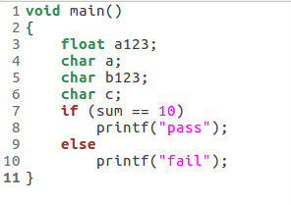
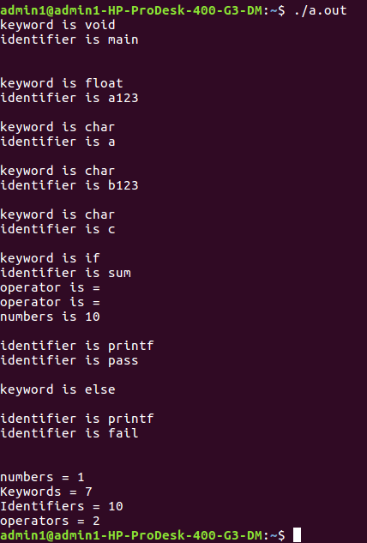
printf("EEK, parse error! Message: "); exit(-1);
}

Output : Input file

- Design, develop and implement a C/C++/Java program to simulate the working of Shortest remaining time and Round Robin (RR) scheduling algorithms. Experiment with different quantum sizes for RR algorithm.
Round-robin (RR) is one of the algorithms employed by process and network schedulers in computing. As the term is generally used, time slices (also known as time quanta) are assigned to each process in equal portions and in circular order, handling all processes without priority (also known as cyclic executive). Round-robin scheduling is simple, easy to implement, and starvation-free. Round- robin scheduling can also be applied to other scheduling problems, such as data packet scheduling in computer networks. It is an operating system concept.

The name of the algorithm comes from the round-robin principle known from other fields, where each person takes an equal share of something in turn.
#include<stdio.h> struct proc
{
int id;
int arrival; int burst; int rem; int wait; int finish;
int turnaround; float ratio;
}process[10]; //structure to hold the process information struct proc temp;
int no;

int chkprocess(int); int nextprocess();
void roundrobin(int, int, int[], int[]); void srtf(int);
main()
{

for(; ;)
{
int n,tq,choice;
int bt[10],st[10],i,j,k;

printf("Enter the choice \n");
printf(" 1. Round Robin\n 2. SRT\n 3. Exit \n");

scanf("%d",&choice); switch(choice)
{
case 1:
printf("Round Robin scheduling algorithm\n"); printf("Enter number of processes:\n"); scanf("%d",&n);
printf("Enter burst time for sequences:"); for(i=0;i<n;i++)
{
scanf("%d",&bt[i]);
st[i]=bt[i]; //service time
}
printf("Enter time quantum:"); scanf("%d",&tq); roundrobin(n,tq,st,bt);
break;

case 2:
printf("\n \n ---SHORTEST REMAINING TIME NEXT---\n \n ");
printf("\n \n Enter the number of processes: "); scanf("%d", &n);
srtf(n);
break;

case 3: exit(0);
}// end of switch

}// end of for
}//end of main()

void roundrobin(int n,int tq,int st[],int bt[])
{
int time=0;
int tat[10],wt[10],i,count=0,swt=0,stat=0,temp1,sq=0,j,k; float awt=0.0,atat=0.0;
while(1)
{
for(i=0,count=0;i<n;i++)
{
temp1=tq;
if(st[i]==0) // when service time of a process equals zero then

//count value is incremented
{
count++;
continue;
}
if(st[i]>tq) // when service time of a process greater than time

//quantum then time
st[i]=st[i]-tq; //quantum value subtracted from service time
else
if(st[i]>=0)
{
temp1=st[i]; // temp1 stores the service time of a process
st[i]=0; // making service time equals 0
}

sq=sq+temp1; // utilizing temp1 value to calculate turnaround time
tat[i]=sq; // turn around time
} //end of for

if(n==count) // it indicates all processes have completed their task because the count value
break; // incremented when service time equals 0
} //end of while

for(i=0;i<n;i++) // to calculate the wait time and turnaround time of each process
{
wt[i]=tat[i]-bt[i]; // waiting time calculated from the turnaround time - burst time
swt=swt+wt[i]; // summation of wait time
stat=stat+tat[i]; // summation of turnaround time
}
awt=(float)swt/n; // average wait time
atat=(float)stat/n; // average turnaround time
printf("Process_no Burst time Wait time Turn around time\n"); for(i=0;i<n;i++)
printf("%d\t\t%d\t\t%d\t\t%d\n",i+1,bt[i],wt[i],tat[i]);
printf("Avg wait time is %f\n Avg turn around time is %f\n",awt,atat);

}// end of Round Robin
int chkprocess(int s) // function to check process remaining time is zero or not
{
int i;
for(i = 1; i <= s; i++)
{
if(process[i].rem != 0)
return 1;
}
return 0;
} // end of chkprocess

int nextprocess() // function to identify the next process to be executed
{
int min, l, i;
min = 32000; //any limit assumed
for(i = 1; i <= no; i++)
{
if( process[i].rem!=0 && process[i].rem < min)
{
min = process[i].rem; l = i;
}
}
return l;
} // end of nextprocess

void srtf(int n)
{
int i,j,k,time=0; float tavg,wavg; for(i = 1; i <= n; i++)
{
process[i].id = i;
printf("\n\nEnter the arrival time for process %d: ", i); scanf("%d", &(process[i].arrival));
printf("Enter the burst time for process %d: ", i); scanf("%d", &(process[i].burst));
process[i].rem = process[i].burst;
}
for(i = 1; i <= n; i++)
{
for(j = i + 1; j <= n; j++)
{

process
if(process[i].arrival > process[j].arrival) // sort arrival time of a

{
temp = process[i]; process[i] = process[j]; process[j] = temp;

}
}
}

no = 0;
j = 1;

while(chkprocess(n) == 1)
{
if(process[no + 1].arrival == time)
{
while(process[no+1].arrival==time)
no++; if(process[j].rem==0)
process[j].finish=time; j = nextprocess();
}
if(process[j].rem != 0) // to calculate the waiting time of a process
{
process[j].rem--;
for(i = 1; i <= no; i++)
{

}
}
else
{
if(i != j && process[i].rem != 0) process[i].wait++;

process[j].finish = time; j=nextprocess();
time--; k=j;
}

time++;
}
process[k].finish = time;
printf("\n\n\t\t\t---SHORTEST REMAINING TIME FIRST---");
printf("\n\n Process Arrival Burst Waiting Finishing turnaround Tr/Tb \n"); printf("%5s %9s %7s %10s %8s %9s\n\n", "id", "time", "time", "time", "time", "time");
for(i = 1; i <= n; i++)
{
process[i].turnaround = process[i].wait + process[i].burst; // calc of turnaround process[i].ratio = (float)process[i].turnaround / (float)process[i].burst;

printf("%5d %8d %7d %8d %10d %9d %10.1f ", process[i].id, process[i].arrival, process[i].burst, process[i].wait, process[i].finish, process[i].turnaround, process[i].ratio);
tavg=tavg+ process[i].turnaround; //summation of turnaround time wavg=wavg+process[i].wait; // summation of waiting time printf("\n\n");

}

tavg=tavg/n; // average turnaround time wavg=wavg/n; // average wait time printf("tavg=%f\t wavg=%f\n",tavg,wavg);

}// end of srtf

Output:
Enter the choice
  - Round Robin 2) SRT
3) Exit 1
Round Robin scheduling algorithm
********************************** Enter number of processes:3
Enter burst time for sequences:24 3
3

Enter time quantum:4
Process_no Burst time Wait time Turnaround time 1 24 6 30
2 3 4 7
3 3 7 10
Avg wait time is 5.666667
Avg turnaround time is 15.666667 Enter the choice
1) Round Robin 2) SRT
3) Exit 2
---SHORTEST REMAINING TIME NEXT---
Enter the number of processes: 4 Enter the arrival time for process 1: 0 Enter the burst time for process 1: 8 Enter the arrival time for process 2: 1 Enter the burst time for process 2: 4 Enter the arrival time for process 3: 2 Enter the burst time for process 3: 9 Enter the arrival time for process 4: 3 Enter the burst time for process 4: 5 1 24 6 30
2 3 4 7
3 3 7 10
---SHORTEST REMAINING TIME FIRST---
Enter the number of processes: 4
Enter the arrival time for process 1: 0 Enter the burst time for process 1: 8 Enter the arrival time for process 2: 1 Enter the burst time for process 2: 4 Enter the arrival time for process 3: 2 Enter the burst time for process 3: 9 Enter the arrival time for process 4: 3 Enter the burst time for process 4: 5
---SHORTEST REMAINING TIME NEXT---

Process Arrival Burst Waiting Finishing turnaround Tr/Tb
id | time | time | time | time | time | time
1 | 0 | 8 | 9 | 17 | 17 | 2.1
2 | 1 | 4 | 0 | 5 | 4 | 1.0
3 | 2 | 9 | 15 | 26 | 24 | 2.7
4 | 3 | 5 | 2 | 10 | 7 | 1.4

tavg=13.000000
wavg=6.500000 Using OpenMP
- Design, develop and implement a C/C++/Java program to implement Banker’s algorithm. Assume suitable input required to demonstrate the results.
The Banker's algorithm, sometimes referred to as the detection algorithm, is a resource allocation and deadlock avoidance algorithm developed by Edsger Dijkstra that tests for safety by simulating the allocation of predetermined maximum possible amounts of all resources, and then makes an "s-state" check to test for possible deadlock conditions for all other pending activities, before deciding whether allocation should be allowed to continue.
The algorithm was developed in the design process for the operating system and originally described (in Dutch) in EWD108. When a new process enters a system, it must declare the maximum number of instances of each resource type that it may ever claim; clearly, that number may not exceed the total number of resources in the system. Also, when a process gets all its requested resources it must return them in a finite amount of time.
#include <stdio.h> #include <stdlib.h> int main()
{
int Max[10][10], need[10][10], alloc[10][10], avail[10], completed[10], safeSequence[10];
int p, r, i, j, process, count; count = 0;

printf("Enter the no of processes : "); scanf("%d", &p);

for(i = 0; i< p; i++) completed[i] = 0;

printf("\n\nEnter the no of resources : "); scanf("%d", &r);

printf("\n\nEnter the Max Matrix for each process : "); for(i = 0; i < p; i++)
{
printf("\nFor process %d : ", i + 1); for(j = 0; j < r; j++)
scanf("%d", &Max[i][j]);
}
printf("\n\nEnter the allocation for each process : "); for(i = 0; i < p; i++)
{
printf("\nFor process %d : ",i + 1); for(j = 0; j < r; j++)
scanf("%d", &alloc[i][j]);
}

printf("\n\nEnter the Available Resources : "); for(i = 0; i < r; i++)
scanf("%d", &avail[i]); for(i = 0; i < p; i++)
for(j = 0; j < r; j++)
need[i][j] = Max[i][j] - alloc[i][j];

do
{
printf("\n Max matrix:\tAllocation matrix:\n");

for(i = 0; i < p; i++)
{
for( j = 0; j < r; j++) printf("%d ", Max[i][j]);
printf("\t\t");
for( j = 0; j < r; j++) printf("%d ", alloc[i][j]);
printf("\n");
}

process = -1;

for(i = 0; i < p; i++)
{
if(completed[i] == 0)//if not completed
{
process = i ;
for(j = 0; j < r; j++)
{
if(avail[j] < need[i][j])
{
process = -1; break;
}
}
}
if(process != -1) break;
}

if(process != -1)
{
printf("\nProcess %d runs to completion!", process + 1); safeSequence[count] = process + 1;
count++;
for(j = 0; j < r; j++)
{
avail[j] += alloc[process][j]; alloc[process][j] = 0;
Max[process][j] = 0;
completed[process] = 1;
}
}
}
while(count != p && process != -1);

if(count == p)
{
printf("\nThe system is in a safe state!!\n"); printf("Safe Sequence : < ");
for( i = 0; i < p; i++)
printf("%d ", safeSequence[i]); printf(">\n");
}
else
printf("\nThe system is in an unsafe state!!");

}

Output:
Enter the no of processes : 5 Enter the no of resources : 3
Enter the Max Matrix for each process : For process 1 : 7 5 3

For process 2 : 3 2 2
For process 3 : 7 0 2
For process 4 : 2 2 2
For process 5 : 4 3 3

Enter the allocation for each process : For process 1 : 0 1 0
For process 2 : 2 0 0
For process 3 : 3 0 2
For process 4 : 2 1 1
For process 5 : 0 0 2
Enter the Available Resources : 3 3 2
Max matrix: Allocation matrix:
7 5 3 | 0 1 0
3 2 2 | 2 0 0
7 0 2 | 3 0 2
2 2 2 | 2 1 1
4 3 3 | 0 0 2

Process 2 runs to completion! Max matrix: Allocation matrix:
7 5 3 | 0 1 0
0 0 0 | 0 0 0
7 0 2 | 3 0 2
2 2 2  4 3 3 | 2 1 1  0 0 2

4 3 3 0 0 2

Process 3 runs to completion! Max matrix: Allocation matrix:
7 5 3 | 0 1 0
0 0 0 | 0 0 0
0 0 0 | 0 0 0
2 2 2 | 2 1 1
4 3 3 | 0 0 2

Process 4 runs to completion! Max matrix: Allocation matrix:
7 5 3 | 0 1 0
0 0 0 | 0 0 0
0 0 0 | 0 0 0
0 0 0 | 0 0 0
4 3 3 | 0 0 2

Process 1 runs to completion! Max matrix: Allocation matrix:
0 0 0 | 0 0 0
0 0 0 | 0 0 0
0 0 0 | 0 0 0
0 0 0 | 0 0 0
4 3 3 | 0 0 2

Process 5 runs to completion! The system is in a safe state!! Safe Sequence: < 2 3 4 1 5 >
- Design, develop and implement a C/C++/Java program to implement page replacement algorithms LRU
and FIFO. Assume suitable input required to demonstrate the results.
In a computer operating system that uses paging for virtual memory management, page replacement algorithms decide which memory pages to page out, sometimes called swap out, or write to disk, when a page of memory needs to be allocated. Page replacement happens when a requested page is not in memory (page fault) and a free page cannot be used to satisfy the allocation, either because there are none, or because the number of free pages is lower than some threshold.
When the page that was selected for replacement and paged out is referenced again it has to be paged in (read in from disk), and this involves waiting for I/O completion. This determines the quality of the page replacement algorithm: the less time waiting for page-ins, the better the algorithm. A page replacement algorithm looks at the limited information about accesses to the pages provided by hardware, and tries to guess which pages should be replaced to minimize the total number of page misses, while balancing this with the costs (primary storage and processor time) of the algorithm itself.
The page replacing problem is a typical online problem from the competitive analysis perspective in the sense that the optimal deterministic algorithm is known.
#include<stdio.h> #include<stdlib.h>
void FIFO(char [ ],char [ ],int,int);
void lru(char [ ],char [ ],int,int);
void opt(char [ ],char [ ],int,int); int main()
{
int ch,YN=1,i,l,f; char F[10],s[25];

printf("\n\n\tEnter the no of empty frames: "); scanf("%d",&f);
printf("\n\n\tEnter the length of the string: "); scanf("%d",&l);
printf("\n\n\tEnter the string: "); scanf("%s",s);
for(i=0;i<f;i++) F[i]=-1;
do
{
printf("\n\n\t*********** MENU ***********"); printf("\n\n\t1:FIFO\n\n\t2:LRU \n\n\t4:EXIT"); printf("\n\n\tEnter your choice: ");
scanf("%d",&ch);

switch(ch)
{
case 1:
for(i=0;i<f;i++)
{
F[i]=-1;
}
FIFO(s,F,l,f);
break; case 2:
for(i=0;i<f;i++)
{
F[i]=-1;
}
lru(s,F,l,f); break;
case 4:
exit(0);
}
printf("\n\n\tDo u want to continue IF YES PRESS 1\n\n\tIF NO PRESS 0 : "); scanf("%d",&YN);
}while(YN==1);return(0);
}
//FIFO
void FIFO(char s[],char F[],int l,int f)
{
int i,j=0,k,flag=0,cnt=0;
printf("\n\tPAGE\t FRAMES\t FAULTS"); for(i=0;i<l;i++)
{
for(k=0;k<f;k++)
{
if(F[k]==s[i]) flag=1;
}
if(flag==0)
{
printf("\n\t%c\t",s[i]); F[j]=s[i];
j++;
for(k=0;k<f;k++)
{
printf(" %c",F[k]);
}
printf("\tPage-fault%d",cnt); cnt++;
}
else
{
flag=0; printf("\n\t%c\t",s[i]); for(k=0;k<f;k++)
{
printf(" %c",F[k]);
}
printf("\tNo page-fault");
}
if(j==f)
j=0;
}
}
//LRU
void lru(char s[],char F[],int l,int f)
{
int i,j=0,k,m,flag=0,cnt=0,top=0; printf("\n\tPAGE\t FRAMES\t FAULTS"); for(i=0;i<l;i++)
{
for(k=0;k<f;k++)
{
if(F[k]==s[i])
{
flag=1; break;
}
}
printf("\n\t%c\t",s[i]); if(j!=f && flag!=1)
{
F[top]=s[i]; j++;
if(j!=f) top++;
}
else
{
if(flag!=1)
{
for(k=0;k<top;k++)
{ F[k]=F[k+1];
}
F[top]=s[i];
}
if(flag==1)
{
for(m=k;m<top;m++)
{ F[m]=F[m+1];
}
F[top]=s[i];
}
}
for(k=0;k<f;k++)
{
printf(" %c",F[k]);
}
if(flag==0)
{
printf("\tPage-fault%d",cnt); cnt++;
}
else
printf("\tNo page fault"); flag=0;
}
}
Output:

Enter the no of empty frames: 3 Enter the length of the string: 5 Enter the string: hello

*********** MENU *********** 1:FIFO
2:LRU
4:EXIT
Enter your choice: 1
PAGE | FRAMES |  |  | FAULTS
h | h |  |  | Page-fault 0
e l | h h | e e | l | Page-fault 1  Page-fault 2
l | h | e | l | No page-fault
o | o | e | l | Page-fault 3

Do u want to continue IF YES PRESS 1 IF NO PRESS 0 : 1

*********** MENU *********** 1:FIFO
2:LRU
4:EXIT
Enter your choice: 2
PAGE | FRAMES | FAULTS
h | h | Page-fault 0
e | h e | Page-fault 1
l | h e l | Page-fault 2
l | h e l | No page fault
o | e l o | Page-fault 3

Do u want to continue IF YES PRESS 1 IF NO PRESS 0 : 1

*********** MENU *********** 1:FIFO
2:LRU
4:EXIT
Enter your choice: 4
- a) Design, develop and implement a C/C++/Java program to simulate a numerical calculator
#include <stdio.h> void main()
{
char operator;
float num1, num2, result;

printf("Simulation of a Simple Calculator\n"); printf("*********************************\n"); printf("Enter two numbers \n");
scanf("%f %f", &num1, &num2); fflush(stdin);
printf("Enter the operator [+,-,*,/] \n"); scanf("%s", &operator); switch(operator)
{
case '+': result = num1 + num2; break;
case '-': result = num1 - num2; break;
case '*': result = num1 * num2; break;
case '/': result = num1 / num2; break;
default : printf("Error in operationn"); break;
}
printf("\n %5.2f %c %5.2f = %5.2f\n", num1, operator, num2, result);
}

Output:
Simulation of a Simple Calculator
********************************* Enter two numbers
2
3
Enter the operator [+,-,*,/]
+
2.00 + 3.00 = 5.00
b) Design, develop and implement a C/C++/Java program to simulate page replacement technique
#include<stdio.h> int n,nf;
int in[100]; int p[50]; int hit=0; int i,j,k;
int pgfaultcnt=0;

void getData()
{
printf("\nEnter length of page reference sequence:"); scanf("%d",&n);
printf("\nEnter the page reference sequence:"); for(i=0; i<n; i++)
scanf("%d",&in[i]); printf("\nEnter no of frames:"); scanf("%d",&nf);
}

void initialize()
{
pgfaultcnt=0; for(i=0; i<nf; i++)
p[i]=9999;
}

int isHit(int data)
{
hit=0;
for(j=0; j<nf; j++)
{
if(p[j]==data)
{
hit=1; break;
}
}
return hit;
}

int getHitIndex(int data)
{
int hitind;
for(k=0; k<nf; k++)
{
if(p[k]==data)
{
hitind=k; break;
}
}
return hitind;
}

void dispPages()
{
for (k=0; k<nf; k++)
{
if(p[k]!=9999)
printf(" %d",p[k]);
}
}

void dispPgFaultCnt()
{
printf("\nTotal no of page faults:%d",pgfaultcnt);
}

void fifo()
{
initialize(); for(i=0; i<n; i++)
{
printf("\nFor %d :",in[i]);

if(isHit(in[i])==0)
{
for(k=0; k<nf-1; k++) p[k]=p[k+1];
p[k]=in[i]; pgfaultcnt++; dispPages();
}
else
printf("No page fault");
}
dispPgFaultCnt();
}

void optimal()
{
initialize(); int near[50];
for(i=0; i<n; i++)
{
printf("\nFor %d :",in[i]); if(isHit(in[i])==0)
{
for(j=0; j<nf; j++)
{
int pg=p[j]; int found=0;
for(k=i; k<n; k++)
{
if(pg==in[k])
{
near[j]=k; found=1; break;
}
else
found=0;
}
if(!found) near[j]=9999;
}
int max=-9999; int repindex; for(j=0; j<nf; j++)
{
if(near[j]>max)
{
max=near[j]; repindex=j;
}
}
p[repindex]=in[i]; pgfaultcnt++;

dispPages();
}
else
printf("No page fault");
}
dispPgFaultCnt();
}

void lru()
{
initialize(); int least[50];
for(i=0; i<n; i++)
{
printf("\nFor %d :",in[i]); if(isHit(in[i])==0)
{
for(j=0; j<nf; j++)
{
int pg=p[j]; int found=0;
for(k=i-1; k>=0; k--)
{
if(pg==in[k])
{
least[j]=k; found=1; break;
}
else
found=0;
}
if(!found) least[j]=-9999;
}
int min=9999; int repindex; for(j=0; j<nf; j++)
{
if(least[j]<min)
{
min=least[j]; repindex=j;
}
}
p[repindex]=in[i]; pgfaultcnt++;
dispPages();
}
else
printf("No page fault!");
}
dispPgFaultCnt();
}

void lfu()
{
int usedcnt[100];
int least,repin,sofarcnt=0,bn; initialize();
for(i=0; i<nf; i++) usedcnt[i]=0;

for(i=0; i<n; i++)
{

printf("\n For %d :",in[i]); if(isHit(in[i]))
{
int hitind=getHitIndex(in[i]); usedcnt[hitind]++; printf("No page fault!");
}
else
{
pgfaultcnt++; if(bn<nf)
{
p[bn]=in[i]; usedcnt[bn]=usedcnt[bn]+1; bn++;
}
else
{
least=9999; for(k=0; k<nf; k++)
if(usedcnt[k]<least)
{
least=usedcnt[k]; repin=k;
}
p[repin]=in[i]; sofarcnt=0; for(k=0; k<=i; k++)
if(in[i]==in[k]) sofarcnt=sofarcnt+1;
usedcnt[repin]=sofarcnt;
}

dispPages();
}

}
dispPgFaultCnt();
}

void secondchance()
{
int usedbit[50]; int victimptr=0; initialize(); for(i=0; i<nf; i++)
usedbit[i]=0; for(i=0; i<n; i++)
{
printf("\nFor %d:",in[i]); if(isHit(in[i]))
{
printf("No page fault!");
int hitindex=getHitIndex(in[i]); if(usedbit[hitindex]==0)
usedbit[hitindex]=1;
}
else
{
pgfaultcnt++; if(usedbit[victimptr]==1)
{
do
{
usedbit[victimptr]=0; victimptr++; if(victimptr==nf)
victimptr=0;
}
while(usedbit[victimptr]!=0);
}
if(usedbit[victimptr]==0)
{
p[victimptr]=in[i]; usedbit[victimptr]=1; victimptr++;
}
dispPages();

}
if(victimptr==nf) victimptr=0;
}
dispPgFaultCnt();
}

int main()
{
int choice; while(1)
{
printf("\nPage Replacement Algorithms\n1.Enter data\n2.FIFO\n3.Optimal\n4.LRU\n5.LFU\n6.Second Chance\n7.Exit\nEnter your choice:");
scanf("%d",&choice); switch(choice)
{
case 1:
getData(); break;
case 2:
fifo(); break;
case 3:
optimal(); break;
case 4:
lru(); break;
case 5:
lfu(); break;
case 6:
secondchance(); break;
default:
return 0; break;
}
}
}

Output:
Page Replacement Algorithms 1.Enter data
- FIFO
- Optimal 4.LRU
- LFU
- Second Chance 7.Exit
Enter your choice:1
Enter length of page reference sequence:8 Enter the page reference sequence:2
3
4
2
3
5
6
2

Enter no of frames:3

Page Replacement Algorithms 1.Enter data
- FIFO
- Optimal 4.LRU
- LFU
- Second Chance 7.Exit
Enter your choice:2

For 2 : 2
For 3 : 2 3
For 4 : 2 3 4
For 2 :No page fault For 3 :No page fault For 5 : 3 4 5
For 6 : 4 5 6
For 2 : 5 6 2
Total no of page faults:6
Page Replacement Algorithms 1.Enter data
- FIFO
- Optimal 4.LRU
- LFU
- Second Chance 7.Exit
Enter your choice:3

For 2 : 2
For 3 : 2 3
For 4 : 2 3 4
For 2 :No page fault For 3 :No page fault For 5 : 2 5 4
For 6 : 2 6 4
For 2 :No page fault Total no of page faults:5
Page Replacement Algorithms 1.Enter data
- FIFO
- Optimal 4.LRU
- LFU
- Second Chance 7.Exit
Enter your choice:4

For 2 : 2
For 3 : 2 3
For 4 : 2 3 4
For 2 :No page fault! For 3 :No page fault! For 5 : 2 3 5
For 6 : 6 3 5
For 2 : 6 2 5
Total no of page faults:6
Page Replacement Algorithms 1.Enter data
- FIFO
- Optimal 4.LRU
- LFU
- Second Chance 7.Exit
Enter your choice:5

For 2 : 2
For 3 : 2 3
For 4 : 2 3 4
For 2 :No page fault! For 3 :No page fault! For 5 : 2 3 5
For 6 : 2 3 6
For 2 :No page fault! Total no of page faults:5
Page Replacement Algorithms 1.Enter data
- FIFO
- Optimal 4.LRU
- LFU
- Second Chance 7.Exit
Enter your choice:7

6. Viva Questions

Define system software.
System software is computer software designed to operate the computer hardware and to provide a platform for running application software. Eg: operating system, assembler, and loader.

What is an Assembler?
Assembler for an assembly language, a computer program to translate between lower-level representations of computer programs.

Explain lex and yacc tools
  - Lex: - scanner that can identify those tokens
  - Yacc: - parser.yacc takes a concise description of a grammar and produces a C routine that can parse that grammar.

Explain yyleng?
Yyleng-contains the length of the string our lexer recognizes.

What is a Parser?
A Parser for a Grammar is a program which takes in the Language string as it's input and produces either a corresponding Parse tree or an Error.

What is the Syntax of a Language?
The Rules which tells whether a string is a valid Program or not are called the Syntax.

What is the Semantics of a Language?
The Rules which gives meaning to programs are called the Semantics of a Language.

What are tokens?
When a string representing a program is broken into sequence of substrings, such that each substring represents a constant, identifier, operator, keyword etc of the language, these substrings are called the tokens of the Language.

What is the Lexical Analysis?
The Function of a lexical Analyzer is to read the input stream representing the Source program, one character at a time and to translate it into valid tokens.

How can we represent a token in a language?
The Tokens in a Language are represented by a set of Regular Expressions. A regular expression specifies a set of strings to be matched. It contains text characters and operator characters. The Advantage of using regular expression is that a recognizer can be automatically generated.

How are the tokens recognized?
The tokens which are represented by an Regular Expressions are recognized in an input string by means of a state transition Diagram and Finite Automata.

Are Lexical Analysis and Parsing two different Passes?
These two can form two different passes of a Parser. The Lexical analysis can store all the recognized tokens in an intermediate file and give it to the Parser as an input. However it is more convenient to have the lexical Analyzer as a co routine or a subroutine which the Parser calls whenever it requires a token.

How do we write the Regular Expressions?
The following are the most general notations used for expressing a R.E.
Symbol | Description
| | OR (alternation)
() | Group of Subexpression
* | 0 or more Occurrences
? | 0 or 1 Occurrence
+ | 1 or more Occurrences
{n,m} | n-m Occurrences

What are the Advantages of using Context-Free grammars?
⇒ It is precise and easy to understand.
⇒ It is easier to determine syntactic ambiguities and conflicts in the grammar.

If Context-free grammars can represent every regular expression, why do one needs R.E at all?
⇒ Regular Expression are Simpler than Context-free grammars.
⇒ It is easier to construct a recognizer for R.E than Context-Free grammar.
⇒ Breaking the Syntactic structure into Lexical & non-Lexical parts provide better front end for the Parser.
⇒ R.E are most powerful in describing the lexical constructs like identifiers, keywords etc while Context-free grammars in representing the nested or block structures of the Language.

What are the Parse Trees?
Parse trees are the Graphical representation of the grammar which filters out the choice for replacement order of the Production rules.

What are Terminals and non-Terminals in a grammar?
Terminals:- All the basic symbols or tokens of which the language is composed of are called Terminals. In a Parse Tree the Leafs represents the Terminal Symbol.
Non-Terminals:- These are syntactic variables in the grammar which represents a set of strings the grammar is composed of. In a Parse tree all the inner nodes represents the Non-Terminal symbols.

What are Ambiguous Grammars?
A Grammar that produces more than one Parse Tree for the same sentences or the Production rules in a grammar is said to be ambiguous.

What is bottom up Parsing?
The Parsing method is which the Parse tree is constructed from the input language string beginning from the leaves and going up to the root node.
Bottom-Up parsing is also called shift-reduce parsing due to its implementation. The YACC supports shift-reduce parsing.

What is the need of Operator precedence?
The shift reduce Parsing has a basic limitation. Grammars which can represent a left-sentential parse tree as well as right-sentential parse tree cannot be handled by shift reduce parsing. Such a grammar ought to have two non-terminals in the production rule. So the Terminal sandwiched between these
two non-terminals must have some associability and precedence. This will help the parser to understand which non-terminal would be expanded first.

What is exit status command?
Exit 0- return success, command executed successfully.
Exit 1 – return failure.

Define API’s
An application programming interface (API) is a source code based specification intended to be used as an interface by software components to communicate with each other.

